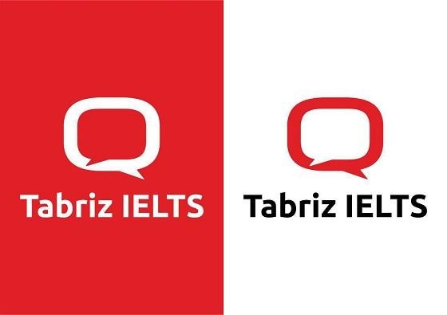
Possessions
- What's your most valued possession?
- Can you remember the last gift you were given? Did you like it?
- Do you ever buy 'gifts' for yourself?
- What do you think of this saying, "Possessions rot, rust, and decay but compassion lasts forever"?
- Have you ever given away something by accident? What was it? How did you give it away by accident?
- What is the meaning of "give and take"? What does this mean to you?
- Do you spend more money on temporary things (services/food/drink/a good night out) or on physical objects (a car, a cellphone, some good books)?
- Can you take something out of your pocket, bag, or wallet?
- What is it?
- Where did you get it?
- Why did you get it?
- Do you still find it useful, interesting or entertaining?

Complied by: Tabriz IELTS Teachers

